**Mass Vaccination Against COVID-19 in Población of**

**Nasugbu, Batangas Simulation**

**Airamin C. Bautista**

Bachelor of Science in Computer Science

Technological University of the Philippines – Manila

**Lhester B. Castuciano**

Bachelor of Science in Computer Science

Technological University of the Philippines – Manila

**Lorence Joy G. De Guzman**

Bachelor of Science in Computer Science

Technological University of the Philippines – Manila

**Maria Au Chiqui Chi R. Zabala**

Bachelor of Science in Computer Science

Technological University of the Philippines – Manila

**Abstract**

As the spread of COVID-19 virus continuously evolving, different countries have begun to distribute and commence vaccination to many people all over the world. It is proven to be that COVID-19 vaccine is considered essential to avail yourself of in order to obtain immunization and strong protection against illness, hospitalization, and worst of all, death. Intending to have a proper and orderly process of distributing vaccines to people in vaccination sites, here in the Philippines, the government created a plan on how to distribute the vaccines in an organized and proper way. The goal of this paper is to implement efficient and immediate vaccination without having disturbance, confusion, or uncertainty by creating different stations with assigned works (registration, counseling, screening, vaccination, etc.). This study describes a simulation program that was created to help with the design and operation of mass vaccination facilities in Población of Nasugbu, Batangas. The simulation model was created by gathering the data of the vaccination clinic through a one-on-one interview from a trusted healthcare facilitator. The data collected consist of the following, namely number of residents per población that will receive the vaccine, number of stations in the site as well as its processing times that represent different processes. Considering various setups and configurations, the system allows users to estimate how many people can be vaccinated and how many workers are required to manage such facilities efficiently. This project will utilize the use of Simio, a simulation software. The associated model can serve as the foundation for assisting public health workers and frontliners in evaluating and comprehending the results of mass vaccination.

**Keywords:** COVID-19 Virus, Mass Vaccination, Simulation Model, Simio.

1. **INTRODUCTION**

The COVID-19 pandemic's forced lockdown has boosted efforts to identify efficient SARS-CoV-2 countermeasures. Though there are many unanswered questions regarding how SARS-CoV-2 may develop in the future, scientists think the COVID-19 pandemic can be stopped most effectively if an effective vaccine is developed and widely used. Worldwide, many institutes and laboratories are funding vaccine research and development to help susceptible people acquire resistance to contamination.

A massive portion of susceptible people should obtain the vaccine to acquire resistance to the numerous diseases in a short time to contain the COVID-19 pandemic, significantly lower hospitalization, morbidity, and mortality rates, and in the interim, reopen the economy. In order to reduce future human and financial repercussions, quick mass vaccination should be implemented, much like in prior fatal pandemic cases, as soon as vaccine production reaches the point at which it can be made available to the general public. One of the most challenging public health initiatives of the ten-year period would be implementing the COVID-19 vaccination on such a vast scale. From the standpoint of preparation and planning, this translates into numerous local mass vaccination stations that provide immunization services in each city and town.

The first phase of vaccine development will be followed by the production, distribution, and dispensing stages, each of which will present unique logistical and socioeconomic obstacles. A lot of planning and preparation must go into the simultaneous supply, distribution, and administration of the vaccine to billions of people. The timely and effective dispensing of vaccines is crucial to their creation, manufacture, and distribution, and it calls for extensive forethought and preparation on many levels. This includes, but is not limited to, vaccination delivery strategies, public education campaigns, and immunization facility layouts and designs.

In this study, a simulation tool created for planning and managing mass vaccination facilities is introduced. Users may visualize the flow and process of receiving a COVID-19 shot due to the simulation tool. Public health planners and decision-makers can use the simulation to assess and comprehend the effects of their mass immunization initiatives. This will display the number of individuals and the time between each station and the vaccination procedure in order to avoid having packed clinics or vaccination locations. Creating simulation technologies that increase capacities and facilitate planning and preparation has become crucial in this setting.

1. **BACKGROUND**

Using mass vaccination campaigns to combat infectious diseases has been standard practice. Different mass vaccination strategies can be utilized in the case of COVID-19 to enable more comprehensive access to all societal segments once a vaccine is made widely available or a need for widespread flu immunization becomes apparent.

In addition to using the established and conventional sites of dispensing facilities, such as clinics, pharmacies, schools, workplaces, and barangay amenities, mass vaccination against COVID-19 would also necessitate the development of new and creative vaccination strategies. This is because some of the aforementioned settings and facilities may be dangerous or ineffective for immunization during a lethal infectious disease. There is a strong propensity for a crowded environment that will require people to come into direct contact with others. Even though many of these locations have been utilized for mass vaccination campaigns, extra precautions must be taken while using them for the COVID-19 immunization campaign to guarantee that vaccination sites maintain a safe physical distance.

The use of analytical or simulation approaches is rare or nonexistent in many clinics and hospitals. Health care systems like hospitals, clinics, and medical centers have been modeled using simulation technology. Additionally, other formal methods have been used. Predicting how a physical model will function in the real world is extremely helpful for people in interpreting and analyzing a digital version of the model. Additionally, the simulation model was created to assist project planners in making adjustments to crucial design elements including the number of individuals permitted to receive vaccinations on a given day, the number of consent form distribution lanes, and the number of consent form fill-in locations.

1. **REVIEW OF RELATED LITERATURE**

This chapter includes multiple related literature and studies which are related to the researchers’ topic. The following research studies will serve as guidelines so as to implement and design a model framework for simulating a mass vaccination site.

**Simulating a Mass Vaccination Clinic**

In the study of Aaby et al. (2005). with a research title of Simulating a Mass Vaccination Clinic stated that in order to assess the effectiveness of mass vaccination clinics, this research examined the use of discrete-event simulation models. Simulation models can measure the lines that form during clinic operations and can estimate how long it takes patients to see a doctor on average. By reducing the number of patients in the clinic, county health departments can plan their operations and prevent unneeded congestion, crowding, and confusion. To aid planners in visualizing what would happen, simulation models also include animation of the clinic operations. In addition, variability, which can come from a variety of sources, is what causes congestion in mass dispensing and immunization clinics. According to the experimental findings provided in this study, clinic performance is significantly more affected by arrival time variability than by patient-related variability. Furthermore, due to the batch procedures and common processing time distributions that define mass dispensing and vaccination clinics, simulation offers the most accurate estimations of queueing. Since it takes time to gather and analyze data, create, and validate the model, and run experiments to assess options, simulation studies like the one described here are best used as part of the planning process for a county's response to an incident.

**Optimizing Planning and Design of COVID‑19 Drive‑through Mass Vaccination Clinics by Simulation**

Based on the study of Asgary et al. (2021). entitled Optimizing planning and design of COVID‑19 drive‑through mass vaccination clinics by simulation. Drive-through clinics have been used in vaccination campaigns in the past, but they are now being adopted more frequently for the COVID-19 vaccination in various parts of the world due to their many benefits, which include making use of existing infrastructure, achieving high daily throughput, and naturally enforcing social distance. Drive-through facilities must have a good site and pay close attention to their layout and process design in order to be successful, effective, and efficient. The researchers’ employed a variety of integrated discrete event simulation (DES) and agent-based modeling techniques to illustrate the potential role that high fidelity computer simulation may play in the planning and design of drive-through mass vaccination clinics. It has seen that simulations were indeed beneficial in helping to optimize the UCHealth drive by identifying potential bottlenecks, overflows, and queueing, and by determining the required number of support workers, through the design and administration of mass vaccination clinics. The intended number of vaccines and necessary processing times for various drive-through station setups and clinic designs were determined using simulation results. They discovered that effective planning, design, and operations management of mass vaccination facilities may be accomplished with the aid of contemporary simulation tools with cutting-edge visual and analytical capabilities.

**Modelling Vaccination Capacity at Mass Vaccination Hubs and General Practice Clinics**

As specified in the study of Hanly et al. (2021). entitled Modelling vaccination capacity at mass vaccination hubs and general practice clinics. Using two modalities of delivery—a huge mass vaccination hub and a small GP vaccination clinic—the researchers have employed queueing simulation approaches to model the vaccine process. They calibrated the delivery modes for each type of the maximum number of arrivals that might be immunized in an eight-hour period while keeping two queue performance metrics—staff utilization and overall processing time—within acceptable ranges. The research findings offer estimates of the daily throughput that these various vaccine distribution methods under various personnel levels could achieve. These simulations indicate that, while maintaining a fixed queue performance, the daily vaccination capacity scales linearly with personnel capacity. Nevertheless, there are several additional elements of the vaccine delivery process that probably provide economies of scale. For instance, a high-capacity post-vaccination area observation area could be supervised by a single staff member provided a low rate of adverse events. Since the cold-chain must be meticulously maintained throughout the entire vaccine transport and handling process, economies-of-scale are likely to apply to vaccine transport as well. For example, it may be logistically easier and more economical to coordinate a single delivery to one central hub rather than numerous deliveries to numerous smaller clinics. Having said that, this analysis demonstrated that mass vaccination hubs are better positioned to scale up daily throughput with a fixed staff capacity while maintaining acceptable queue performance by emphasizing our baseline models. It is also explained that mass vaccination hubs are more tolerant of employee absences or the redeployment of some staff to other critical tasks.

1. **METHODOLOGY**

**Simulation Method**

In developing this project entitled “Mass Vaccination Against COVID-19 in Población of Nasugbu, Batangas Simulation”, we used a simulation approach, the Discrete-event Simulation (DES). For the purpose of this project, we used the Simio simulation software. It is a tool for developing and using dynamic systems models so you can see how they perform and evaluate their performance.

The method we used in this project is the Discrete Event Simulation (DES). DES is a flexible and intuitive method that is used to simulate a real-world system. In order to determine the most effective and efficient model, this simulation method is typically used to examine and evaluate numerous operational what-if scenarios and tactics. Before choosing one option over another, decision-makers can predict the effects of that choice using DES. It is typically used when field-based testing and investigations are expensive or infeasible. This simulation method is frequently used in medical facilities and health care settings. The DES works well for modeling drive-through processes with a road network with a series of discrete events that automobiles must pass through as they wait in lines to obtain various services.

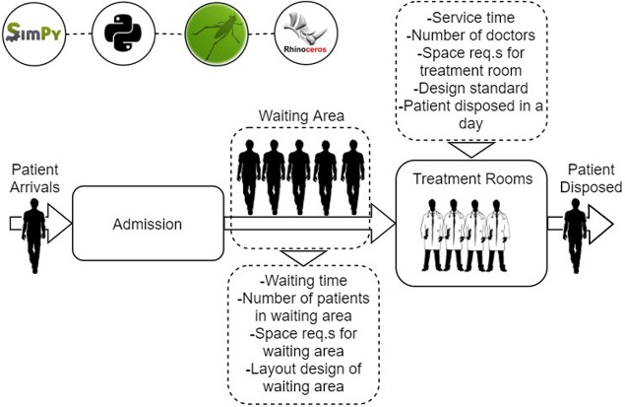

*An Example of Discrete-Event Simulation*

**Simulation Layouts**

To develop the vaccination simulation, first, we make a sketch plan based on the auditorium layout and transfer this design to simulation software. The predetermined vaccination site was located in Nasugbu, Batangas, in front of the Nasugbu Municipality Hall. This auditorium was chosen to be the vaccination site, where it met most of the required site selection criteria of a good mass vaccination place. It has a sufficient space that can accommodate more than 100 persons (vaccinees and health professionals combined) and have good ventilation that can reduce the concentration of airborne contaminants such as viruses like COVID-19. The vaccination site is composed of 6 areas with designated roles and functions.

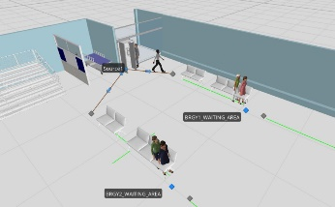 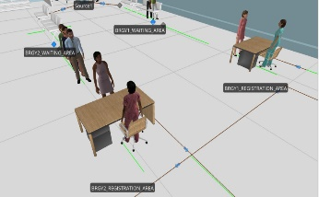

*Waiting Area Registration Area*

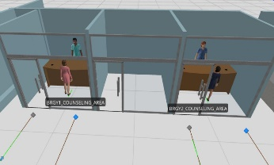 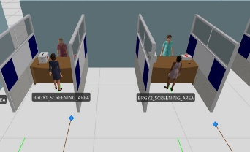

*Conseling Area Screening Area*

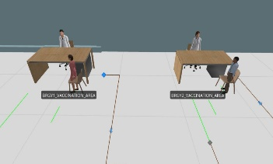 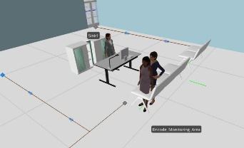

*Vaccination Area Encoding and Monitoring Area*

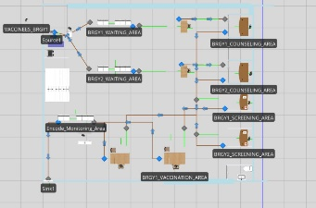 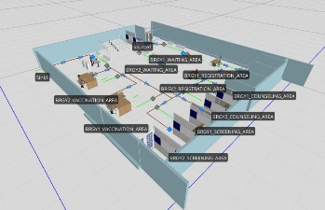

*2D of Vaccination Simulation 3D of Vaccination Simulation*

**Simulation Flow and Processes**

The figure shown below is the flow of every vaccinee or patient in COVID-19 Mass Vaccination.

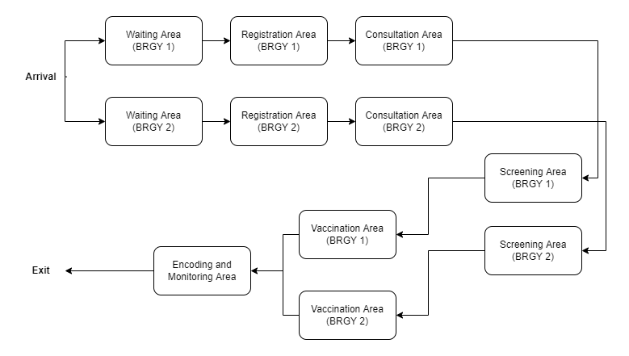

*Flowchart of Mass Vaccination in Nasugbu, Batangas*

After entering the vaccination site, each vaccinee is asked to line up or queue in their respective waiting area to practice social distancing. They receive registration forms to fill out the information. After waiting, each vaccine will proceed to the registration area to submit its registration forms. The registration station has two tables, each with a registration staff.

At the consultation station, each vaccinee will discuss possible complications with a doctor or nurse. There is two consultation staff to accommodate the vaccines. In this area, they will be discussing common side effects, symptoms, complications, history of illness, and more.

After this, each vaccinee walked to the screening station. Vaccinees waited in a single line at the screening station to see medical personnel. There is two screening staff in this area. The screening staff checked each vaccinees registration form. Staff directed patients who had possible complications based on their medical history to visit the consultation station.

At the vaccination station, patients waited in one line to see vaccination personnel. There were two stations with vaccination staff. Vaccination staff verified that the consent form was signed and witnessed and then vaccinated the patient in one arm.

The last station is the encoding and monitoring area. In this station, the patient and another staff member reviewed an information sheet about what to do after the vaccination, recorded and encoded the vaccines information, and every vaccine must be monitored for 30 minutes to observe if there were bad reactions in the body of every vaccine after receiving a vaccine. If each vaccine goes well, they can now exit the vaccination site.

1. **RESULTS AND DISCUSSION**

We will describe the simulation and the simulation setup for the result and discussion. Also, we will define the data we used in our vaccination simulation, the simulation software used, and any other details related to the project. We will introduce how we implement the simulation based on the simulation approach mentioned, the Discrete-Event Simulation (DES). After that, we will test the simulation and give out the result to prove the implementation of our project.

**Simulation and Simulation Setup**

For the implementation of our vaccination simulation, we used data provided by the Nasugbu Rural Health Unit (Nasugbu RHU), Simio Simulation Software for creating, modeling, and simulating the vaccination site. After processing and applying the gathered data to the simulation software, we were able to implement our vaccination simulation.

**Data Used for Simulation**

The data provided by the Nasugbu Rural Health Unit in our vaccination simulation is composed of the location of the vaccination site, the date and time of vaccination, the total of vaccinees per day, the total number of vaccinees in each barangay, the six stations or areas of vaccination with their corresponding number of that area, allotted time, and their assigned roles or functions.

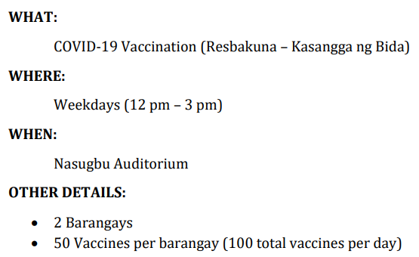

*Data Used in Vaccination Simulation Provided by the Nasugbu Rural Health Unit*

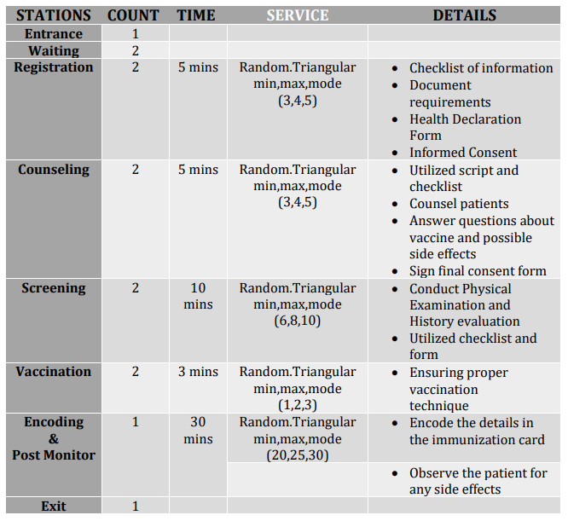

*6 Stations/Areas in Vaccination Site with their Corresponding Count, Time, Service, and Details*

**Simulation Software Used**

The initial plan for our project was to use AnyLogic or Arena Simulation Software, but we ended up using Simio Simulation Software as our simulation tool. Simio is simulation software that offers a real object-based 3D modeling environment together with scheduling capabilities to aid in optimizing the use of essential resources and evaluating the risk involved with operational choices. Users may build their 3D model using this platform in a single step and then instantaneously transition to a 3D view. Using this simulation tool, we were able to utilize a discrete event model with 3D visualization of the vaccination site using the Simio software.

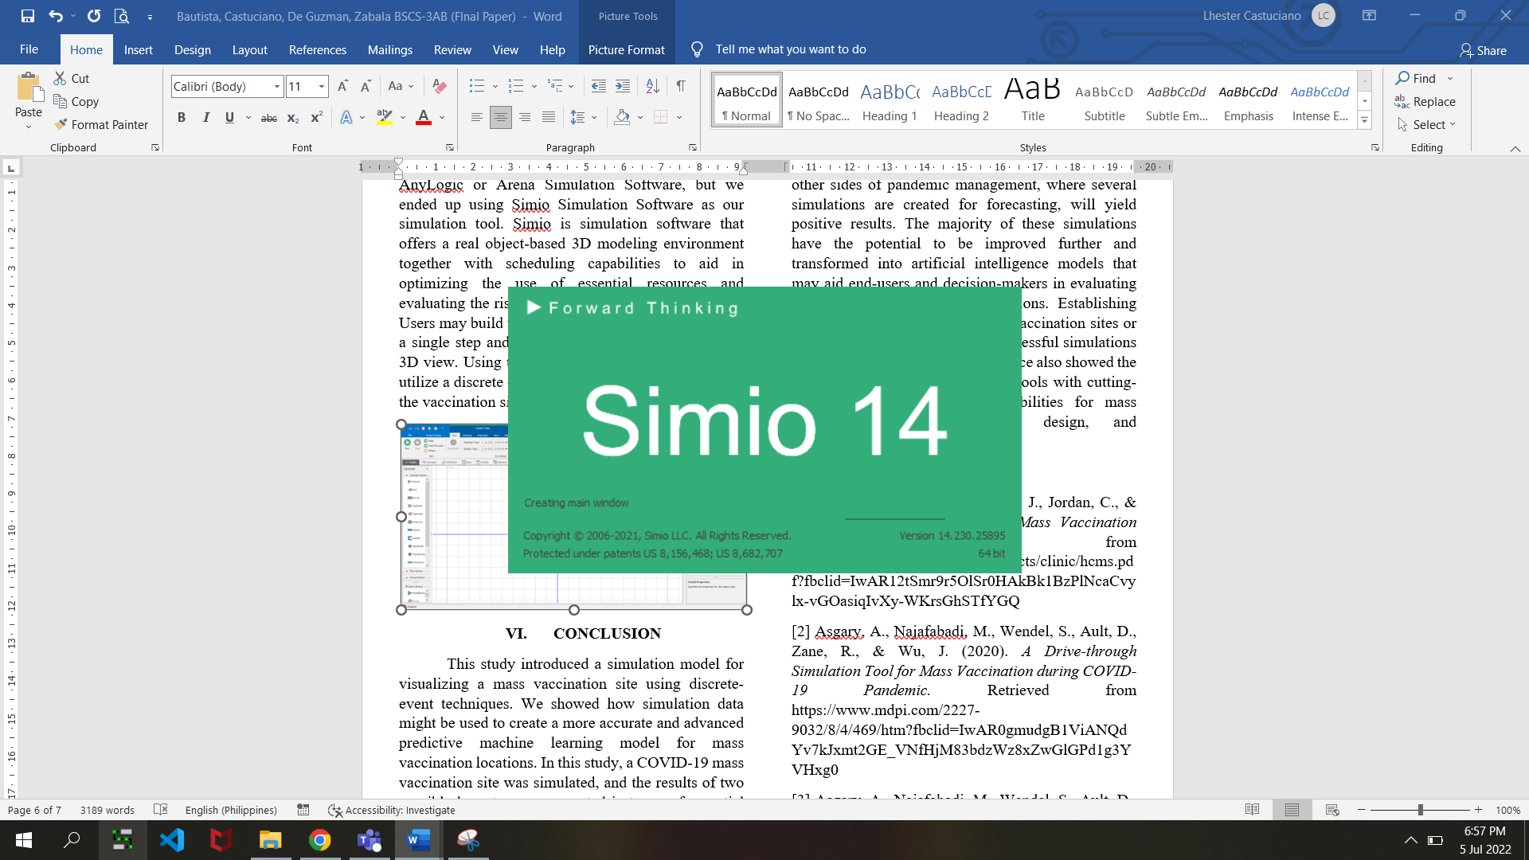

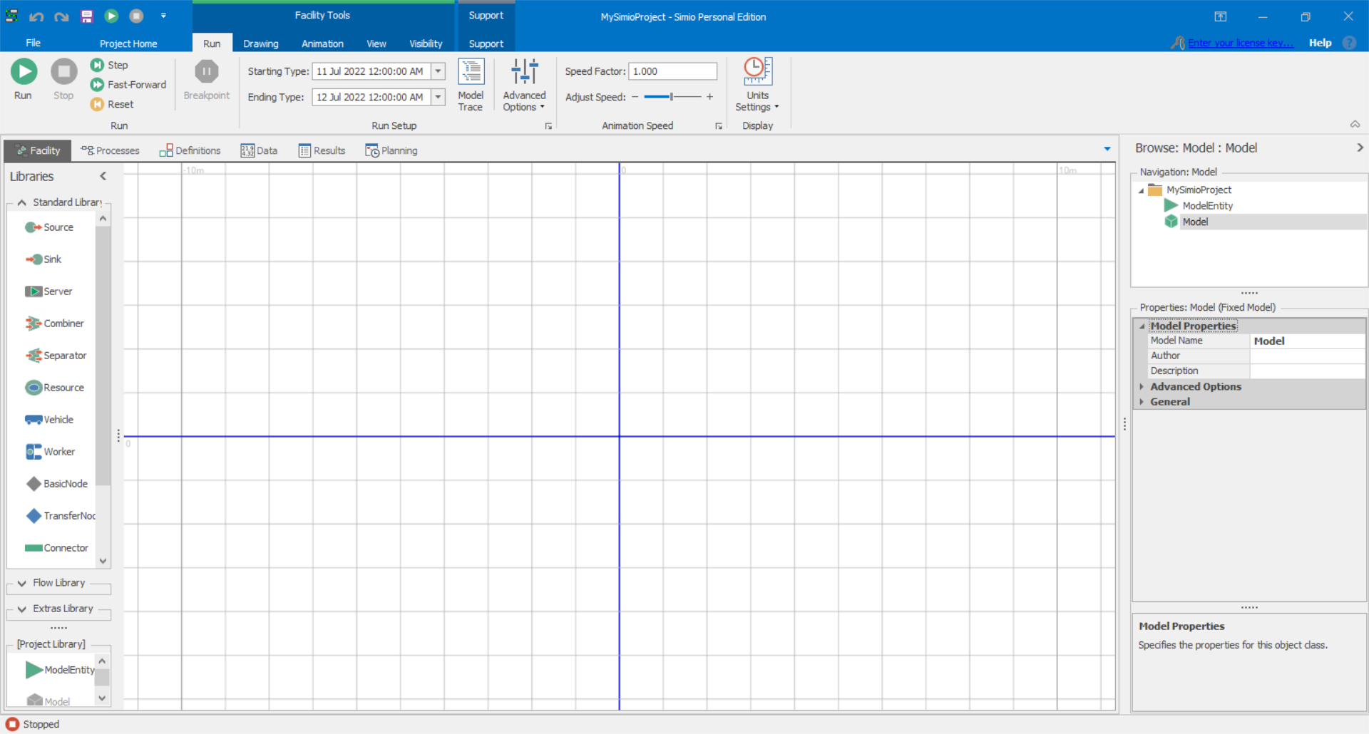

*Simio Simulation Software Used in Implementing our Vaccination Simulation*

**Simulation Sequence and Result**

The development of our simulation is completed after modeling our vaccination site with Simio Simulation Software and adding the information or data provided by the Nasugbu Rural Health Unit to each entity's attribute. The simulation tool generates a sequence of each barangay that is shown below.

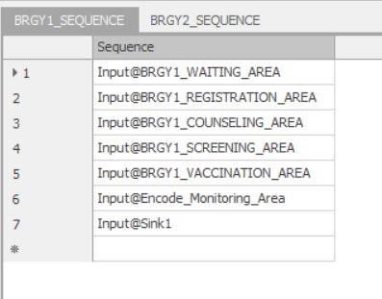 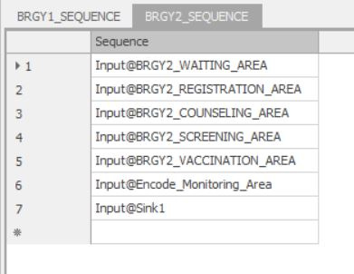

*Sequence of Barangay 1 and Barangay 2*

Acquiring accurate data for each entity of this vaccination simulation is an essential aspect of model performance. Using the provided data, we produced a model that is relatively realistic. The comparison of different event or scenarios to determine the ideal course of action or the consequences of an intended course. The picture below shows the event or scenario that happened at the vaccination site using a simulation tool with its result.

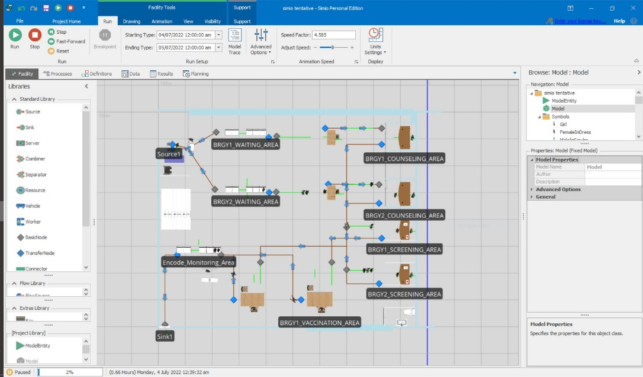

*Scenario or Event in vaccination Site using Simio Simulation Software*

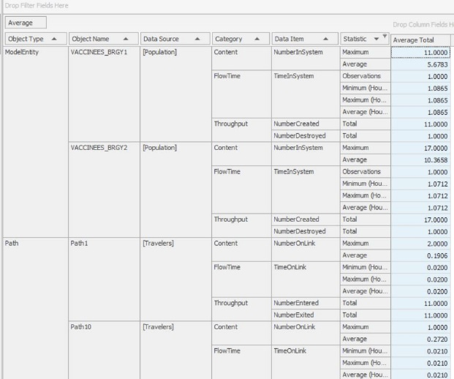

*Result of the Implemented Vaccination Simulation*

**Monte Carlo Simulation**

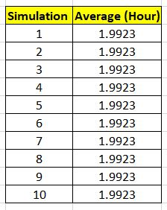

*Result of Simulating the Model*

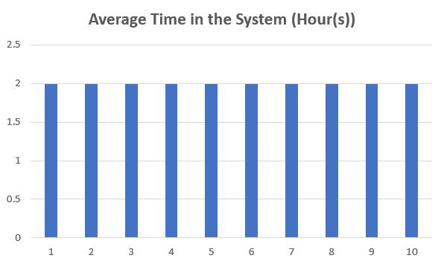 The probability of various outcomes in a process that cannot be easily anticipated due to the interference of random factors is modeled using Monte Carlo simulations. In this study, The Vaccination Model was simulated at least ten times to prove that the model is closed to reality which means that every patient in the Mass Vaccination in the Poblacion of Nasugbu Batangas takes up to approximately 2 hours.

*Graph of the Average Time of the Simulation Model*

1. **CONCLUSION**

This study introduced a simulation model for visualizing a mass vaccination site using discrete-event techniques. We showed how simulation data might be used to create a more accurate and advanced predictive machine learning model for mass vaccination locations. In this study, a COVID-19 mass vaccination site was simulated, and the results of two possible layouts were presented in terms of essential performance parameters like the number of vaccinations processed and the overall processing time.

Sites for mass vaccinations are simple to set up and run and have a high throughput. The healthcare decision-makers can use the model described here to plan their actual mass vaccination clinics by specifying input variables and obtaining the results. Under various parameter values, the resulting model can be used to quickly anticipate the number of individuals who will need vaccinations and the typical time required for vaccination. Decision-makers can use the model's scenario-based outputs to assist them in creating the best site or venue for their needs.

The results indicate that using this strategy on other sides of pandemic management, where several simulations are created for forecasting, will yield positive results. The majority of these simulations have the potential to be improved further and transformed into artificial intelligence models that may aid end-users and decision-makers in evaluating the effects of various policy options. Establishing more effective and efficient mass vaccination sites or clinics may be helped by these successful simulations in real-world settings. This experience also showed the value of using modern simulation tools with cutting-edge visual and analytical capabilities for mass vaccination facility planning, design, and management.

**REFERENCES:**

[1] Aaby, K., Cook, D., Herrmann, J., Jordan, C., & Wood, K. (2005). *Simulating a Mass Vaccination Clinic.* Retrieved from https://isr.umd.edu/Labs/CIM/projects/clinic/hcms.pdf?fbclid=IwAR12tSmr9r5OlSr0HAkBk1BzPlNcaCvylx-vGOasiqIvXy-WKrsGhSTfYGQ

[2] Asgary, A., Najafabadi, M., Wendel, S., Ault, D., Zane, R., & Wu, J. (2020). *A Drive-through Simulation Tool for Mass Vaccination during COVID-19 Pandemic.* Retrieved from https://www.mdpi.com/2227-9032/8/4/469/htm?fbclid=IwAR0gmudgB1ViANQdYv7kJxmt2GE_VNfHjM83bdzWz8xZwGlGPd1g3YVHxg0

[3] Asgary, A., Najafabadi, M., Wendel, S., Ault, D., Zane, R., & Wu, J. (2021). *Optimizing planning and design of COVID‑19 drive‑through mass vaccination clinics by simulation.* Retrieved from https://link.springer.com/content/pdf/10.1007/s12553-021-00594-y.pdf

[4] Hanly, M., Churches, T., Fitzgerald, O., Caterson, I., MacIntyre, C., & Jorm, L. (2021). *Modelling vaccination capacity at mass vaccination hubs and general practice clinics.* Retrieved from https://www.medrxiv.org/content/10.1101/2021.04.07.21255067v1.full.pdf

[5] Asgary, A., Najafabadi, M. M., Karsseboom, R., & Wu, J. (2020). A Drive-through Simulation Tool for Mass Vaccination during COVID-19 Pandemic. *Healthcare (Basel, Switzerland)*, *8*(4), 469. https://doi.org/10.3390/healthcare8040469

[6] Asgary, A., Valtchev, S. Z., Chen, M., Najafabadi, M. M., & Wu, J. (2020). Artificial Intelligence Model of Drive-Through Vaccination Simulation. *International journal of environmental research and public health*, *18*(1), 268. https://doi.org/10.3390/ijerph18010268